Exam 1 Spring 2018

1. Explain what are CPU modes. Explain their uses. How does the CPU know what mode it is in?
2. What is an atomic instruction? What would happen if multiple CPUs/cores execute their atomic instructions?
3. Draw the state diagram of a process from its creation to termination, including all transitions. Make sure you will elaborate every state and every transition in the diagram.
4. What is a context? Provide a detail description of all activities of a context switch.
5. Do your best to define and compare the concepts of process, thread and fiber. In particular, how are they scheduled?
6. Define the meaning of a race condition? Answer the question first and use execution sequences with a clear and convincing argument to illustrate your answer.
7. Design a C program segment so that the main() creates two child processes with fork(), each of these two child processes creates two child processes, etc. such that the parent child relationship is a perfectly balanced binary tree of depth n with main() at the root. The depth n has already been stored a valid positive integer. The main() prints its PID, and each child process prints its PID and its parent’s PID.
8. Consider the following two processes, A and B, to be run concurrently using a shared memory for the int variable x. Assume that x is initialized to 0, and x must be loaded into a register before further computations can take place. What are all possible values of x after both processes have terminated?

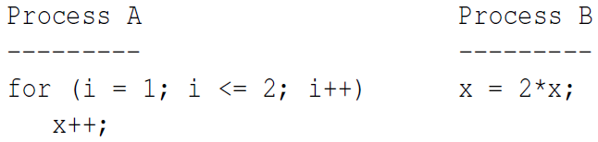

1. Consider the following solution to the mutual exclusion problem for two processes P1 and P2. This solution uses two global int variables, x and y. Both x and y are initialized to 0. Prove rigorously that this solution satisfies the mutual exclusion condition.

